Case 1-Asia-Japan-Hokkaido-Mount Tokachi-Hand Axe and Scraper-20,000 BCE

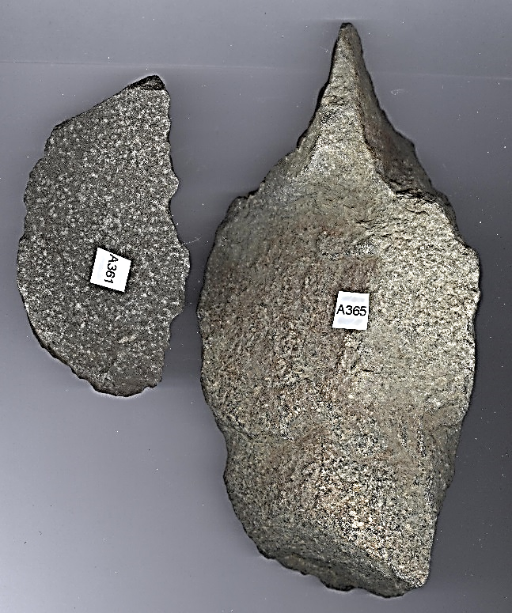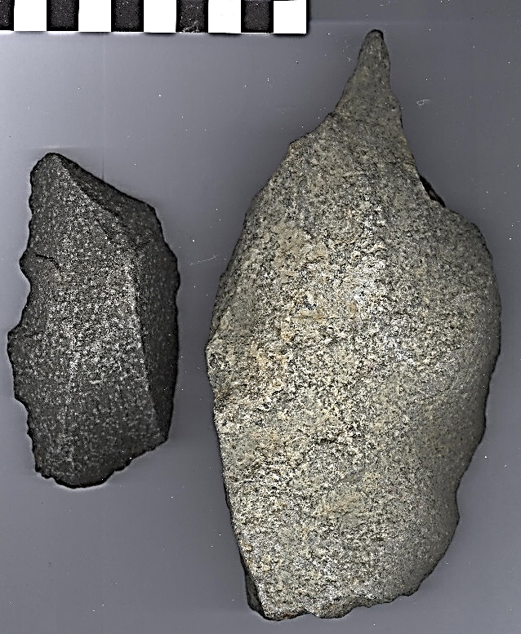

Figs. 1-2. Hokkaido-Mount Tokachi-Hand Axe and Scraper-20,000 BCE



Fig. 3. Find spot on Mount Tokachi (十勝岳 *Tokachidake*) 2,077 m (6,814 ft) photographed from Mount Biei, Aug. 9, 1998. <https://upload.wikimedia.org/wikipedia/commons/5/57/Mount_Tokachi_from_Mount_Biei_1998-08-09.jpg>

**Formal Label:** Hokkaido-Mount Tokachi-Hand Axe and Scraper-20,000 BCE

**Display Description:**

The zone on Mount Tokachi, in Hokkaido, in which the artifacts were recovered was the habitat of the brown bear in the Paleolithic period, and, in fact, the brown bear is still alive in the area today. In Hokkaido the Ainu have great reverence for brown bears, which provide meat for food, fur for clothing and bone for tools. The Ainu rite of the iyomante or “bear sending ritual” begins in the spring as the bears are awakening from hibernation, a female bear and her cubs are caught, the female bear is killed and her spirit is sent to the gods in a special ceremony. Therefore, it is proposed that these artifacts were used to hunt the female brown bear in spring as the initial part of the Ainu rite of the iyomante or “bear sending ritual. The hand axe was probably used as a halberd, being hafted to a long stick, as a method of dispatching the bear as it was a time before the use of arrows tipped with poison. Once used, the implements of killing the bear are discarded as they are no longer “active” or suitable for killing again. Thus, the hand axe and the scraper were left in place on the mountain where the female bear was killed. The female brown bear would have been skinned on the mountain and her cubs would have been back brought to the hunters’ habitation and raised as members of the family. These artifacts, therefore, if this hypothesis is correct, formed an integral initial part of the Ainu rite of the iyomante or “bear sending ritual.” They were the chief implements that were used to kill and skin the female brown bear and they offer an important insight into the ancientness of the history of the bear ceremony in the lives of the Ainu.

**Accession Number:** A361, A365

**LC Classification:**  [DS832](http://library.lib.asu.edu/search%7ES3?/cDS832+.B319x/cds++832+b319+x/-3,-1,,E/browse)

**Date or Time Horizon:** Paleolithic

**Geographical Area:** Mount Tokachi (十勝岳 *Tokachidake*)

**Map, GPS coordinates: 43.416665 142.6833306**



Fig. 4. Location of Mount Tokachi (十勝岳 *Tokachidake*), Hokkaido. http://latitude.to/img/latitude-logo.svg

**Cultural Affiliation:** Paleolithic

**Medium:** granite

**Dimensions:** hand axe H 6.82 in (17.32 cm), W 3.52 in (89.52 mm); scraper H 4.1 in (99.17 mm). 2.23 in (56.64 mm).

**Weight:**

**Condition: original.**

**Provenance:** Atlantika.

**Discussion:** The second part of iyomante or “bear sending ritual” occurs after the Ainu have raises the male cubs for two years, during which they are provided with the best food and are treated like members of the family. Sometimes they are even given suckle by the women of the family, since the cubs are believed to be gods of the mountain. Then, after two years one male bear is tied to a post in the center of the village and hunters kill it with arrows tipped with a fast-acting poison made from the roots of a small purple-flowered plant called are Aconitum yesoense. The bear is skinned, its hide is dressed and it is placed within an altar that is decorated with gifts to the bear spirit.

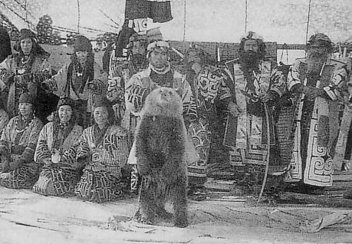

Fig.Iyomante, ca 1930, in https://upload.wikimedia.org/wikipedia/commons/5/52/Iomante1.JPG..

Then the hunters shoot arrows to the east, the place of rebirth, and then these hunters take the bear’s penis (the organ responsible for regeneration) and the head (the organ containing its divine spirit) to a sacred place on Mount Tokachi (the highest mountain in Hokkaido) so its spirit can return to its mountainous abode. Thus, the bear spirit is returned to the place of its initial release to the spirit world and the cycle is completed.

**References:**

Fitzhugh, William W. and ‎Chisato O. Dubreuil. 1999. *Ainu: spirit of a northern people*. Arctic Studies Center, National Museum of Natural History, Smithsonian Institution in association with University of Washington Press.

Inada, T. 1998. “Extinct animals and human in the Palaeolithic period of the Japanese Archipelago*,”* *Sci. J. Kagaku* [Kagaku], 68 (1998): 345 -352.

Nihon Kokugo Daijiten (in Japanese). Tokyo: Shogakukan. 2012